**FRESHERS , DIWALI AND CHRISTMAS CELEBRATION 2025**

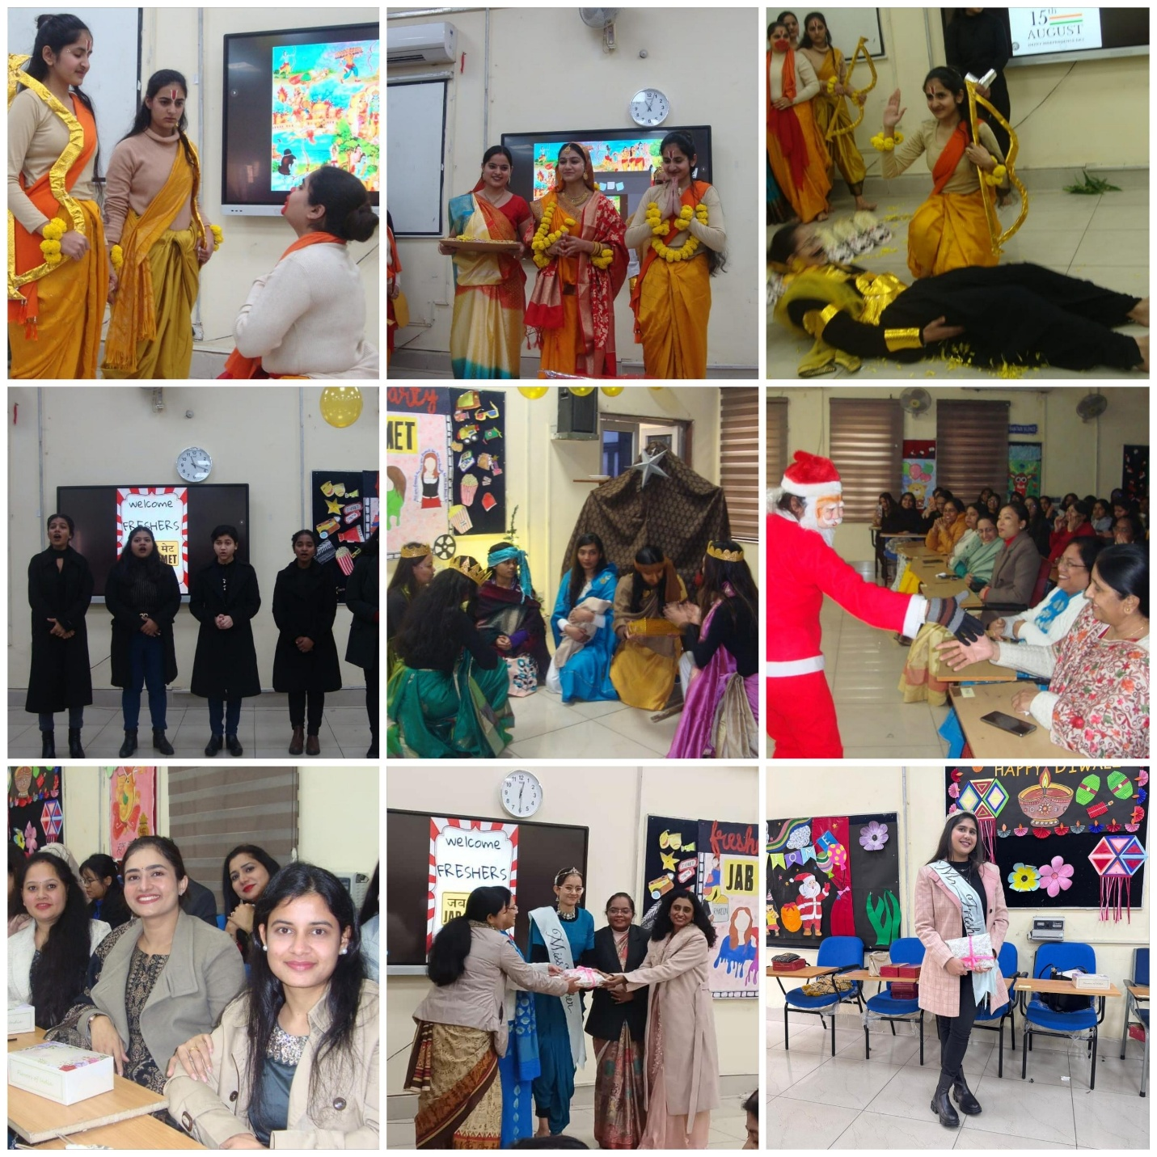

**The students of RAK College Of Nursing organised the Fresher's Party , Diwali and Christmas Celebration.**

**Fresher's Party was organised for the new batch 2024- 2025 for both MSc and BSc**

**First year students .**

**The theme for the Fresher’s Party was “ Jab we Met ”**

**Venue : Assembly Hall**

**Time : 10 A.M to 1 P.M**

**The event started with Lamp lighting ceremony by Respected teachers, followed by welcome dance by BSc Hons Nursing 3rd years . Then, the MSc. First year students were called upon stage for their introduction and performance. Followed by Introduction and performance of BSc . First year students .**

**Students performed Ramayan skit and nativity skit, Carol songs , highlighting the essence of Diwali and Christmas .**

**The prize and results of Miss Fresher’s were announced. From MSc. Miss Antim Rohilla won the title of Miss Fresher and from BSc. Miss Nisha Lata won the title of Miss Fresher.**